Evaluation

In DT this year we have has designed juice cartons

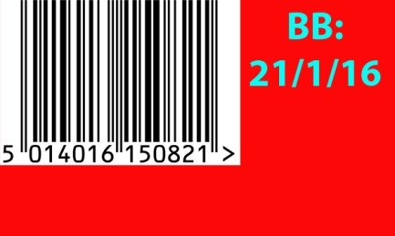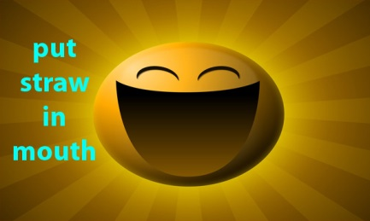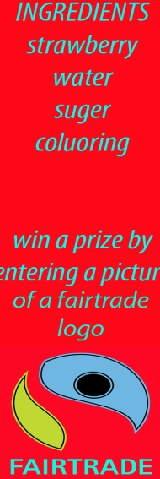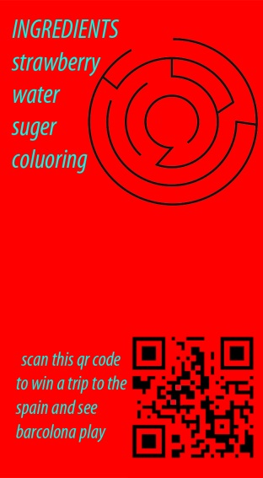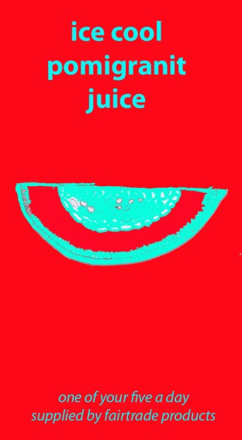For Fairtrade we had to design a front, back, top, bottom and sides. These are my sides that I designed during class

We started this project in September and I finished on the 18th of November 2015.

My evaluation

Things that went well: designing the sides for the carton.

Importing pictures.

Importing my sides into 2D design.